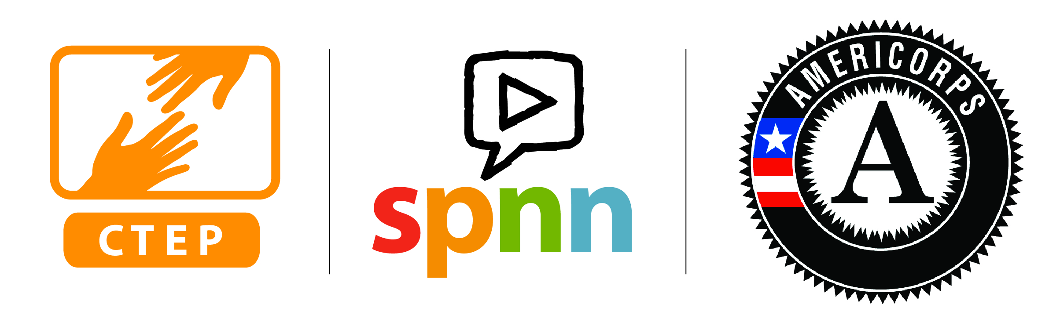
2018-2019
CTEP AMERICORPS
HOST SITE APPLICATION

FOR TWIN CITIES AREA PARTNERS

DIRECTIONS:

1) Please review the Instructions document completely before completing this application.
2) The application has four sections: Host Site, Member Request, CTEP Program, and Program Management. Complete the gray form fields and save the document as you complete it. You will not be able to edit text outside of the form fields. Questions related to the program or the application can be relayed to Joel Krogstad, krogstad@spnn.org, CTEP Program Director.
3) Re-title this application file name by adding your agency name at the beginning. (example: SPPL CTEP Host Site Application 2018-19)
4) Send the application as an email pdf attachment to krogstad@spnn.org by no later than Fri Jan 12, 2018 at 5 PM.

I. HOST SITE INFORMATION

1a. Name of Partner Organization:

1b. Name, Title, Mailing Address, Phone, and Email of Individual Filling Out Application:

1c. Name, Title, Mailing Address, Phone, and Email and of the individual who will be the site supervisor for the CTEP AmeriCorps Member:

1d. Name, Title, Mailing Address, Phone, and Email and of the individual who would sign the host site agreement?

1e. Describe in narrative what evidence exists that proposed CTEP programming at your site would primarily benefit demographics which meet the following three conditions: those who are low-income, are unemployed or underemployed, and have low technology skills. (Max 350 words).

1f. Describe the history of the development of your organization in the past five years. CTEP is interested in placing members at sites that have a track record of stability, and are confident in providing a steady environment during the upcoming program year.

1g. Describe the site environment. Include setting of service position; physical, emotional, and intellectual demands; any special equipment that needs to be used

1h. Describe specifically the role of the Member in programming, who they will be serving (e.g.employment aged-youth, adults, new Americans, etc.] Insert additional special skills needed if any.

1i. How close is your service site to public transport? Will your service site require a vehicle of the Member? CTEP will prioritize sites that have easy access to public transportation within their city as well as public transport to other parts of the Twin Cities area, unless your site meets a unique need within the network.

1j. As AmeriCorps Members should not be seen as a long term staffing solution to any organization, what are your long term plans to deliver enhanced programming without having a member at some point in the future?

1k. If you are seeking to renew our partnership, how many years has your organization hosted a CTEP Member?

1l. Please complete the following checklist to the best of your ability. Mark an X in either the Yes or No column to each requirement, and if you cannot meet one of the requirements please contact CTEP prior to
submission to address any concerns and agree on an alternative plan.

Host Site Requirements | Yes | No
Host Site will play an active role recruiting for their future Member(s) and will follow up with potential candidates in a timely matter

Host site has adequate space for the CTEP Member including a phone with messaging, access to a computer that has internet and email, place to save files electronically, access to printer and copier, access to refrigerator and microwave, place to keep personal belongings. The programming, office space, and bathrooms should also be accessible (example, someone who would need to use a wheelchair)

Supervisor will ensure that the CTEP Member is not replacing work of staff at site

Host Site understands that the role of the CTEP member is only to teach technology literacy skills and implement technology literacy programming. The member should not be used for other kinds of programming (such as general homework help for youth or GED subject matter instruction for adults), provide IT support for your organization, or perform general administrative tasks unrelated to CTEP’s mission.

Host Site will develop a schedule that includes a minimum of 10 hours per week when the CTEP Member is uninterrupted by clients to better concentrate on capacity building projects and direct service preparation

Host Site will reimburse CTEP Member if traveling between service sites

Host Site will pay the site fee within 30 days of the start date of the Member. The site fee must come from a non-federal source, as well as ideally the salary of the site supervisor (for purposes of in-kind contribution).

Host Site understands that all programming that the Member delivers must be free to the participants involved. Host site cannot charge fees for Member-led programming, but may charge fees for other site programming unrelated to the Member’s service.

Host Site will provide site-based orientation during the CTEP Member’s first week

Supervisor will meet with CTEP Member at least a one hour weekly meeting

Supervisor is the only staff Member who will give the CTEP Member service tasks

Supervisor will ensure CTEP Member is not involved in any general site fundraising or other activities prohibited by AmeriCorps (partisan activities, religious activities, etc.)

Supervisor will approve and submit all reporting on time which includes: Timesheets Bi-Weekly, In-Kind Hours Monthly, Quarterly Reports

Supervisor will commit to supervising, training, and working with the CTEP member for an average of 15 hours per month

Supervisor can attend CTEP meetings within Twin Cities area three times a year

II. MEMBER REQUEST

2a. Indicate the number of full-time Members requested for 2018-19:

2b. If you are applying for multiple CTEP members, what is your rank of importance for each different position? (first being the most important) Write the locations of the positions in the fields below.

#1)
#2)
#3)
#4)
#5)
#6)
#7)
#8)

2c. If you are applying for more than one CTEP Member at the same service site, why does your site need more than one Member to perform the described task(s)?

III. CTEP PROGRAM GOALS

3a. What do you think is realistic for numbers of community members who would pass online Northstar technology literacy assessments who could not previously do so? Remember that the assessments would require at least an intermediate level of English to complete and would likely require participants to be regular attendees (four or five sessions minimum) in your programming. The assessments are also available in Spanish language. CTEP will give preference to sites where a minimum of 50 community members will receive certification from a Northstar assessment per CTEP member.

Your programming would need to focus on at least one of the following topics:

# Individuals who will be certified in at least one standard per CTEP member requested

Certifications that your site will administer

Basic Computer Skills
Internet
Email Windows Operating System Mac OS X Operating System
Microsoft Word 2010
Microsoft Excel 2010
Social Media
PowerPoint
Information Literacy

3b. Indicate your goal for number of community members you could confirm were placed in jobs as a result of each Member:

Jobs do not have to be full-time and can be temporary, but must provide pay. CTEP will give preference to sites where at least 18 jobs would be acquired by community members per CTEP member.

3c. What systems would you use at your site to verify employment outcomes of program participants (i.e. case manager, future follow up, display of paystub or acceptance letter, etc)?

Reminder for community media centers: As noted in the instructions, programming can include other technical literacy, such as video editing, as long as through other CTEP approved technical trainings, they also achieve CTEP’s goals for Northstar, employment, and volunteer mobilization.

3d. Describe how each Member would develop the capacity of your organization in the coming year.

3e. Part of the AmeriCorps experience involves helping others in the community become more civically engaged. All CTEP Members must be involved in volunteer mobilization, whether that is supporting existing volunteers, creating volunteer position descriptions, or recruiting new volunteers to work with the project. How will mobilizing volunteers be part of your AmeriCorps Member’s position?

3f. CTEP will give preference to sites where the member will recruit and/or manage a minimum of 15 volunteers per CTEP member over the course of the service year. Work-study or paid interns do not count. What is your goal for number of volunteers recruited/managed per CTEP member requested?

3g. Does your service site plan to use AmeriCorps Members from other programs during the 2018-19 program year? If so, from which programs and how will what the CTEP Members do be unique?

IV. PROGRAM MANAGEMENT

4a. The site fee is $8000 per full-time Member. What is the total site fee amount your organization would pay if allotted your entire request? $

After-school youth technology literacy
Bottom of Form
4b. Is your agency able to provide additional support to the CTEP program beyond the site fee (e.g. discounts on trainings and services to CTEP Members (yours and possibly CTEPs at other sites), facilities space for Member trainings for 35 individuals, subsidy of the Member’s rent, etc.).

4c. If the site supervisor will be new to CTEP, what supervisory experience does the site supervisor have? Does the site supervisor have any previous experience managing AmeriCorps/VISTA members?

4d. Describe what you anticipate as the expected weekly schedule (Monday through Saturday, indicate degree of flexibility if any). The weekly schedule should total 35 hours a week on average, but could include periods of the year that are higher and lower as dictated by programming. Some CTEP members have part-time second jobs, so knowing the site schedule is in many cases a major determinant in which sites a member will select. Of course sites can change the schedule later if they need to.

THANK YOU FOR YOUR INTEREST IN THE CTEP PROGRAM AND WE LOOK FORWARD TO REVIEWING YOUR APPLICATION.

