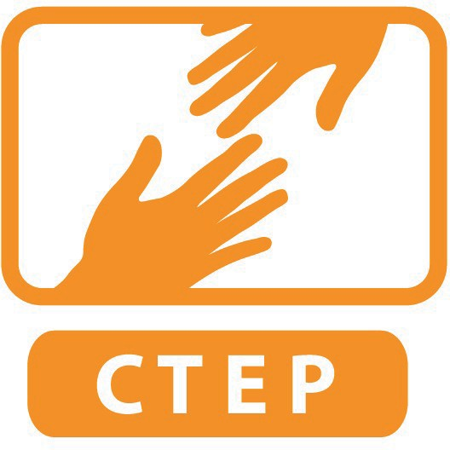
CTEP MEMBER SERVICE PLAN
DUE FIRST CORPS DAY IN OCTOBER

NAME OF MEMBER:
NAME OF SITE SUPERVISOR:
NAME OF SERVICE SITE:

Date Reviewed and Approved by both Supervisor and Member:

DIRECTIONS:
The purpose of the Service Plan is to solidify expectations of the member once they have been at the site a month. Please upload plan to your shared CTEP folder in your SPNN Google. Make sure document has the file name “MemberFirstnameLastName ServicePlan ProgramYears.” Please also make sure that both supervisor and member have a copy of this completed document. CTEP staff may ask site to revise the service plan periodically over the course of the year so that it remains current.

You will need to refer to the Service Plan Instructions PDF in order to complete this plan.

AGREED UPON SERVICE SCHEDULE:

- DIRECT SERVICE ACTIVITIES

Narrative of all Direct Service Activities (include dates when helpful):

NORTHSTAR GOALS

Highlight which Northstar assessments you will concentrate on at your site:
Basic Computer Skills | Microsoft Word | Social Media
Internet Basics | Microsoft Excel | Information Literacy
Using Email | Microsoft PowerPoint | Supporting K-12 Distance Learning
Windows | Google Docs | Career Search Skills
Mac OS Basics |  | Your Digital Footprint

Highlight any CTEP Customized assessments you will incorporate at your site:
3D Printing: General | GarageBand | Resume Writing
3D Printing: Keychain | Job Search | Video Conferencing
Adobe Premiere Pro Editing | Laser Engraver | Writer Duet for Screenplays
Basic Google Suite | Making Media | Making Media: Distance Learning
Digital Photography Portfolio

Additional notes:

Please estimate:

 | # Participants who will take a Northstar Digital Literacy post assessment this year
 | # Participants who become certified in Northstar this year
 | # Participants certified from this site last year (if applicable)
By reporting quarter |  | Minimum suggested outcome:
 | # new people certified between Jan 3- Mar 20 | 20
 | # new people certified between Mar 21-Jun 19 | 20
 | # new people certified between Jun 20- Aug 31 | Any remainder

EMPLOYMENT GOALS

# of participants you can verify become employed this year over the course of the year
# of participants the CTEP member verified became employed last year (if applicable)

Describe your site’s system to find out if someone found a job:

CAPACITY BUILDING PROJECTS

Project 1 Title:
Estimated Date to Complete:
Project Narrative:

Project 2 Title:
Estimated Date to Complete:
Project Narrative:

Project 3 Title:
Estimated Date to Complete:
Project Narrative:

PLAN TO RECRUIT AND/OR MANAGE VOLUNTEERS

Narrative of Plan to Recruit and/or manage volunteers:

# Volunteers recruited over course of this year
# Volunteers managed over course of this year
# Volunteers recruited last year (if applicable)
# Volunteers managed last year (if applicable)

What are three efficient volunteer management practices the member will implement for the year? : Practice #1:

Practice #2:

Practice #3:

