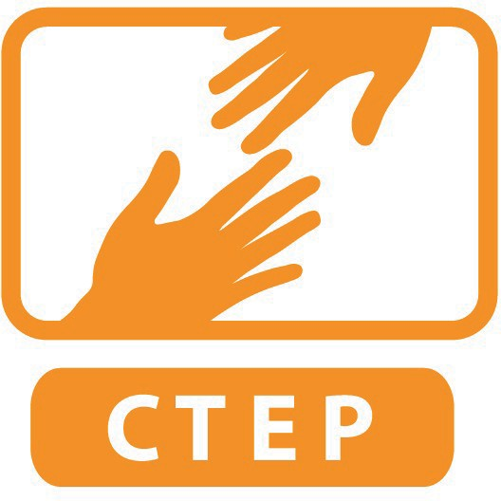
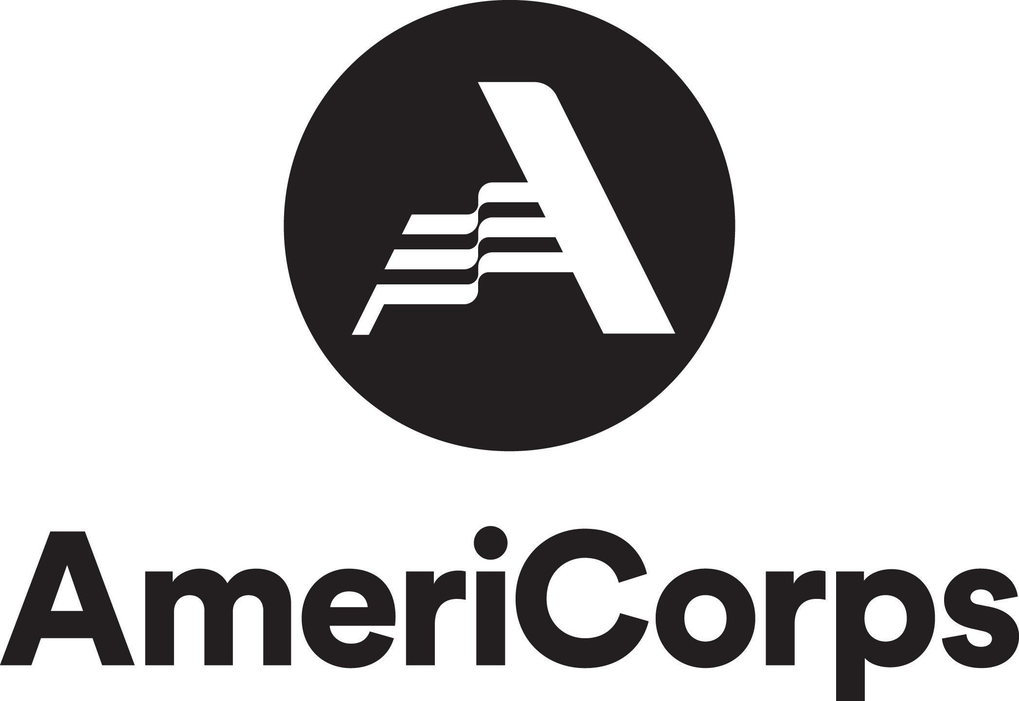
CTEP Exit Interview Questions

DIRECTIONS: Please answer the questions below electronically with good detail and upload it to your member folder at least one day prior to your exit interview. Do not complete this form before the last month of your service year. This document will not be reviewed by your site supervisors, but only CTEP staff.

Member Name:
Site:
Name of Site Supervisor:
Date Completed:

- What was the highlight of your service this year?

- Do you feel you made a difference at your site? In your community? For individuals?

- Did you feel that you benefited from civic engagement activities? Why or why not?

- What was the best or most rewarding part of working at your site?

- What was the toughest or most challenging part of working at your site?

- What did your site supervisor do well?

- How could your site supervisor improve support of the CTEP member?

- What did the CTEP staff/program do well?

- What could CTEP staff/program improve?

- Are there other issues that you wanted to talk about?

- What are your future plans? Do you think your AmeriCorps service experience this past year will benefit you in your future?

