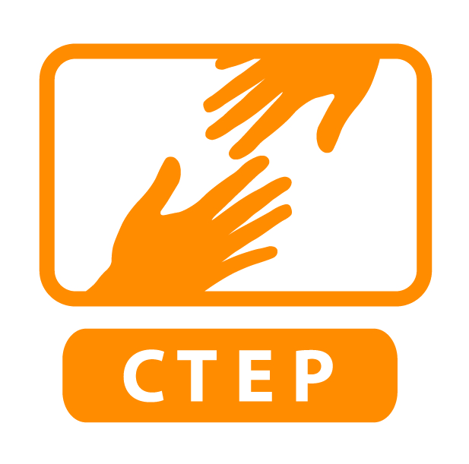
WEEKLY SUPERVISOR/MEMBER CHECK-IN
Check out the NY Times article about Project Oxygen, a multimillion dollar research initiative by Google to find out what makes a good manager. All that money came up with some very common sense suggestions, which we like because they are short and sweet and manageable to implement. Here’s a suggested format for structuring your check-ins with your CTEP member & to practice strong management.
Check in with member—Personal (3-5 minutes)
Ask a couple short questions about their life. How are they doing outside work? Something to show you care about them, their life/professional goals.

Asking and Listening (15-20 minutes)
Ask member generally about successes in the past week.
Ask member generally about challenges.
Ask follow up questions like, what do you attribute these to? And how could you solve that? Propose short targeted solutions to challenges and resources after listening first.
Programming (Remaining amount of minutes will vary)
Ask about specific upcoming programming and tasks and how the member will achieve them.
Concrete Task List
Create an ongoing to-do list with member that you can check in about the following week (possibly on a shared Google document, or in a place that you can share).
Need Other Support?
Ask whether the member needs any other support, or if they see any roadblocks that you could help remove.
Wrap up and Schedule Next Weekly Meeting
Make sure meeting times are consistent and that you are not changing, cancelling, or rescheduling more than once a month.

“Hallway Follow-Ups”
Follow up with the member in the next few days to track progress and/or to ask if they need support in some way. If you don’t share a space (like an office or are in a different building), send the member an email or communicate in some other way to touch base.

CTEP developed the supervisor/member check-in format above with a group of CTEP members who expressed what they wanted their supervisor check-ins to be like. One member said of the meeting format: “This looks really good. Like, REALLY good. This is kind of what I am picturing for how I wish the meetings would go, but again, it always seems so rushed and one-sided, if you will, when we meet. I would rather have a conversation with a supervisor than just a delegating meeting. Those are of course OK, and helpful to just ‘get it done,’ but I want them to know really me and understand my accomplishments at my site.”

