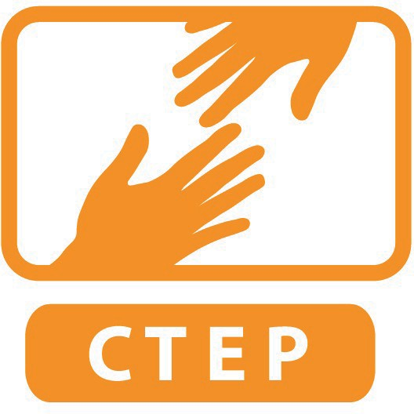
CTEP MEMBER SERVICE PLAN
DUE FIRST CORPS DAY IN OCTOBER

NAME OF MEMBER:
NAME OF SITE SUPERVISOR:
NAME OF SERVICE SITE:

Date Reviewed and Approved by both Supervisor and Member:

DIRECTIONS:
The purpose of the Service Plan is to solidify expectations of the member once they have been at the site a month. Please upload plan to your shared CTEP folder in your SPNN Google Drive by the 1st Corps Day in October. Make sure document has the file name “MemberFirstnameLastName ServicePlan ProgramYears.” Please also make sure that both supervisor and member have a copy of this document. CTEP staff may ask site to revise the service plan periodically over the course of the year so that it remains current.

You will need to refer to the Service Plan Instructions PDF in order to complete this plan.

AGREED UPON SERVICE SCHEDULE:

- DIRECT SERVICE ACTIVITIES

Narrative of all Direct Service Activities (include dates when helpful):

NORTHSTAR GOALS

Which Northstar assessments will you concentrate on at your site?:
Basic Computer Skills | Word Processing (Word) | Email | Social Media
Internet | Operating System | Excel | Typing (through other approved sites)

PowerPoint (available Fall 2015) Information/Media Literacy (available Spring 2016?)

Please estimate:

 | # Participants who will take a Northstar Digital Literacy post assessment this year
 | # Participants who become certified in Northstar this year
 | # Participants certified from this site last year (if applicable)
By reporting quarter |  | Minimum suggested outcome:
 | # people certified between Sept 8- Nov 15 | 10
 | # new people certified between Nov 16- Mar 20 | 20
 | # new people certified between Mar 21- Jun 19 | 20
 | # new people certified between Jun 20- Aug 31 | Any remainder

EMPLOYMENT GOALS

# of participants you can verify become employed this year over the course of the year
# of participants the CTEP member verified became employed last year (if applicable)

Describe your site’s system to find out if someone found a job:

CAPACITY BUILDING PROJECTS

Project 1 Title:
Estimated Date to Complete:
Project Narrative:

Project 2 Title:
Estimated Date to Complete:
Project Narrative:

Project 3 Title:
Estimated Date to Complete:
Project Narrative:

PLAN TO RECRUIT AND/OR MANAGE VOLUNTEERS

Narrative of Plan to Recruit and/or manage volunteers:

# Volunteers recruited over course of this year
# Volunteers managed over course of this year
# Volunteers recruited last year (if applicable)
# Volunteers managed last year (if applicable)

What are three efficient volunteer management practices the member will implement for the year? : Practice #1:

Practice #2:

Practice #3:

