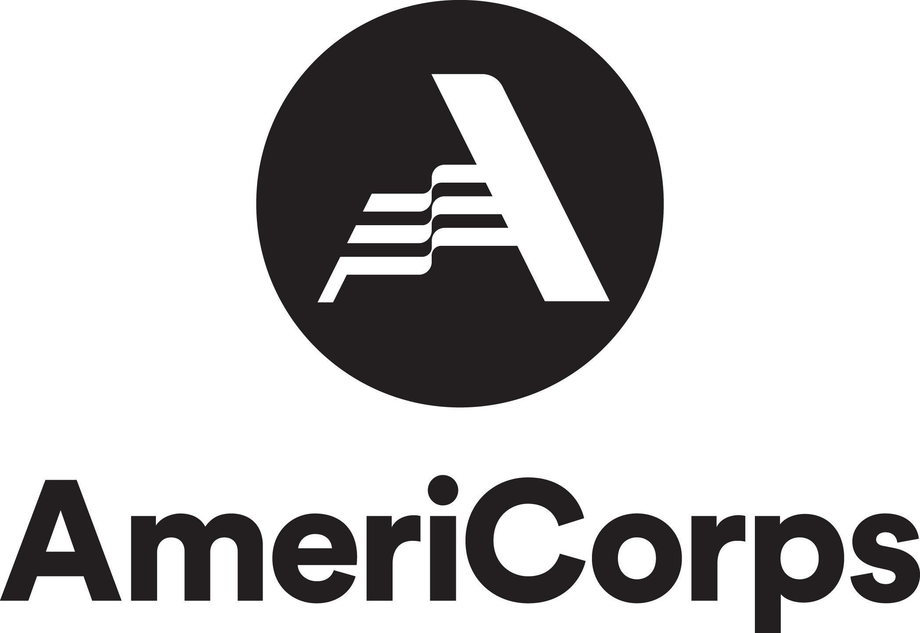
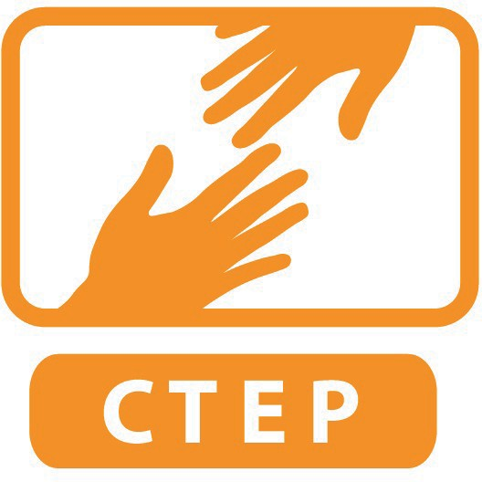
CTEP EXIT CHECKLIST
Use this as a guide to ensure that you complete all the requirements of the program. All should be done at least one day prior to your exit interview with CTEP staff (contact staff prior to interview with any concerns).

Name of Member:
Date of Exit Interview:
Will complete or already completed at least 1720 hours of service (see member contract); There are no outstanding timesheets that need to be submitted by the member or approved by the site supervisor.
Took no more than 4 personal days for CTEP required training events (see member contract);
Completed the mid-year and end-of-term performance evaluations with site supervisor; and submitted both site supervisor and member copies to CTEP staff in member folder
Completed all site reporting on member tracking sheet
Direct service
Volunteer mobilization
Capacity building projects
Mission moments, photos and media releases in member folder
Submitted Hand Off Document to site supervisor/CTEP staff in member folder
Submitted Group Civic Engagement Written Reflection emailed to CTEP staff
Turned in All Financial Receipts related to Health Insurance or Civic Engagement
Completed Part 1 of online AmeriCorps Exit Form (to bring to exit interview)
Uploaded End of Year Survey Questions to member folder at least one day before exit interview

FOR CTEP STAFF USE ONLY
Has this member completed the required number of hours? □ Yes
□No
Has this member satisfactorily completed assignments, tasks, or projects? □ Yes □No Has this member met any other criteria which had been clearly communicated both orally and in writing at the beginning of the term of service? □ Yes □ No

