
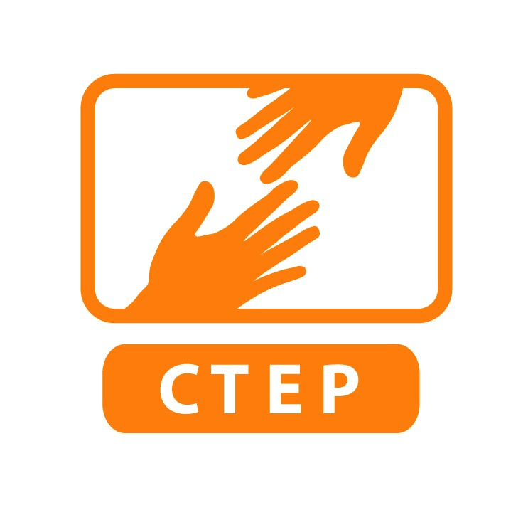
CTEP AmeriCorps Member Performance Review
Year End Evaluation

Member Self-Evaluation Supervisor Eval of Member
Member Name:
Site Supervisor Name: Site:
CTEP AmeriCorps members undertake a performance review twice during their service terms, once halfway into their service term and then a year end evaluation which is completed in the member’s final month of service. Members serving less than half time service years only complete a year end review. These performance reviews are a federal requirement for the member to complete successfully.

CTEP’s process is that the member self-evaluates his or her own performance, and site supervisor will also complete an evaluation of the member’s performance. Then site supervisor and member will then arrange a time to discuss their separate reviews, sign their names on both versions indicating that a conversation of member’s performance took place, and finally submit both signed copies to CTEP staff. There does not need to be a hybrid version where you have to come to agreement between the member and supervisor reviews. Copies should be made for the member as well as the site. Please note that this form is not meant for members to evaluate their site supervisor or site. Members regularly evaluate the performance of their sites with bi-weekly surveys submitted to CTEP as well as during the Exit Interview with CTEP staff. CTEP recommends that site supervisors regularly incorporate time for member feedback into their weekly meetings.

Part I: Please rate member’s work performance as it relates to the following:
 | Not satisfactory | Okay | Good | Very good | Excellent
Dependability: member is consistently punctual, completes tasks in appropriate amount of time, calls in appropriately if unable to come in, avoids schedule conflicts
Communication (e.g. ability to communicate with staff from diverse backgrounds, communication is appropriate for work environment, member keeps others informed)
Exhibits professional behavior in appearance and attitude
Creative and/or resourceful in carrying out tasks
Understands and follows site procedures and policies
Demonstrates a Service Ethic indicative of AmeriCorps principle of “Getting Things Done”
Has developed skills related to their position during course of service
Relates positively to site staff
Accepts and uses feedback for personal development
Demonstrates initiative, group leadership, and facilitation skills
Organizational skills: effectively prepares to provide technology literacy services
Demonstrates concern for the quality, accuracy and completeness of tasks performed
Submits all relevant paperwork (timesheets and other) in a timely manner
Effectively prioritizes between multiple tasks

Part II: Please respond to the following questions:

1. Illustrate some of the significant impacts that this AmeriCorps member has had on the program:

2. Briefly discuss the special strengths the member has demonstrated:

3. Discuss area(s) which member should focus on to improve their effectiveness in future positions:

4. Please rate members overall performance:
Not satisfactory
Satisfactory
Good
Very Good
Excellent

5. Supervisor and Member are confident that member will complete service hours by end of service term.
Yes
No
If no, what is plan to complete hours?

Print, sign and date, confirming a conversation of member’s performance took place between member and site supervisor:

___________________________________________________________________________________
Member Date

___________________________________________________________________________________
Site Supervisor Date

